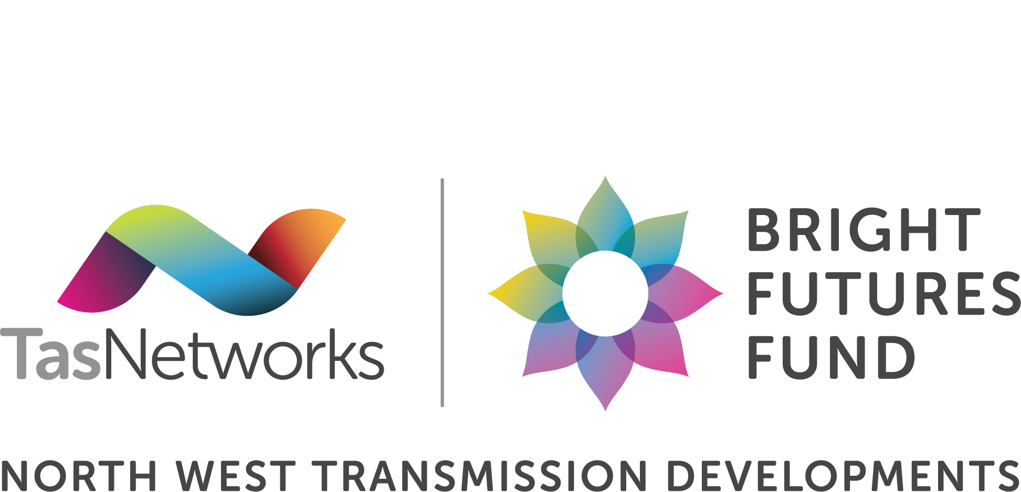
Ambassador Pack
About the Bright Futures Fund
The North West Transmission Developments (NWTD) project is upgrading the electricity network across the north and north west, and as part of that, TasNetworks is investing $10 million into local communities through the Bright Futures Fund (BFF).
The program is launching on 19 June 2026, with applications for the first round of funding open until 2 August.
Co-designed with communities, the Bright Futures Fund is focused on creating a positive, lasting legacy.
An Independent Community Assessment Panel helps to decide where the funding goes.
Applications are open to community-led projects, big or small, offering four funding tiers ranging from a few thousand to several hundred thousand dollars across areas including health and wellbeing, environment, arts, skills, community infrastructure and more.
To be eligible, projects must benefit one of the five local government areas (LGAs) that the North West Transmission Developments project spans: Burnie City, Central Coast, Kentish, Meander Valley or Northern Midlands.
As an ambassador, the posts and content blocks below are ready to personalise and share. Help spread the word and encourage your networks to apply.

Ambassador Social Post Templates
Written in first-person peer voice.
Post 1: General awareness
[I/we] are getting behind something [I/we] think could make a real difference for our community.
The North West Transmission Developments is investing $10 million into local projects through the Bright Futures Fund, and they're looking for ideas from people and organisations just like [us].
Grant applications are open to community-led projects, big or small, offering funding ranging from a few thousand to several hundred thousand dollars. If your idea benefits your community, it's worth putting forward.
An independent panel of locals helps to decide where the funding goes.
What does a bright future look like for YOUR community? 💡
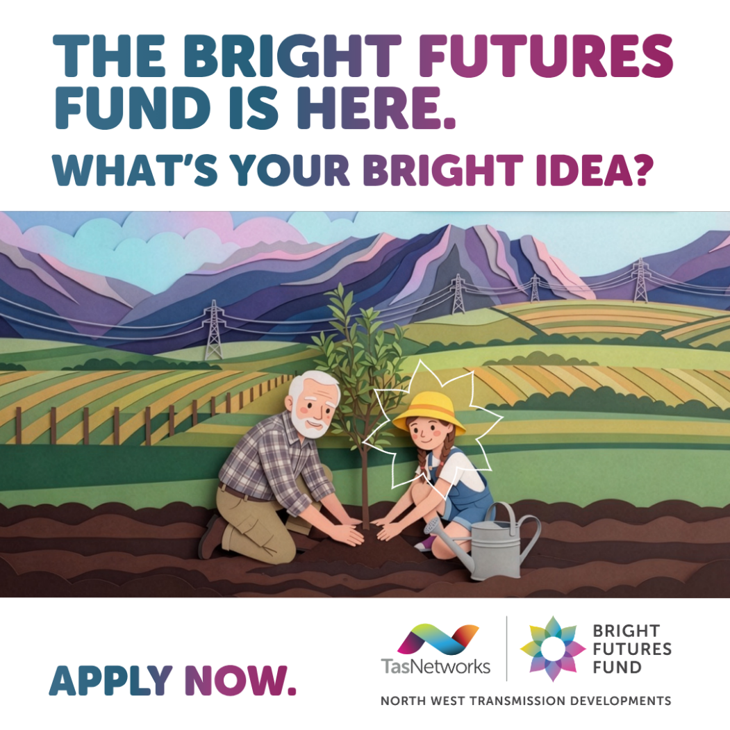
www.tasnetworks.com.au/brightfuturesfund

Post 2: Personal endorsement
[I'm a champion for] the North West Transmission Developments Bright Futures Fund because our region has no shortage of bright ideas, just sometimes a shortage of funding.
This is a real opportunity: $10 million for projects across health, environment, arts, education and more, invested into communities across the North and North West.
If you've got an idea, or know someone who does, please share this.
www.tasnetworks.com.au/brightfuturesfund
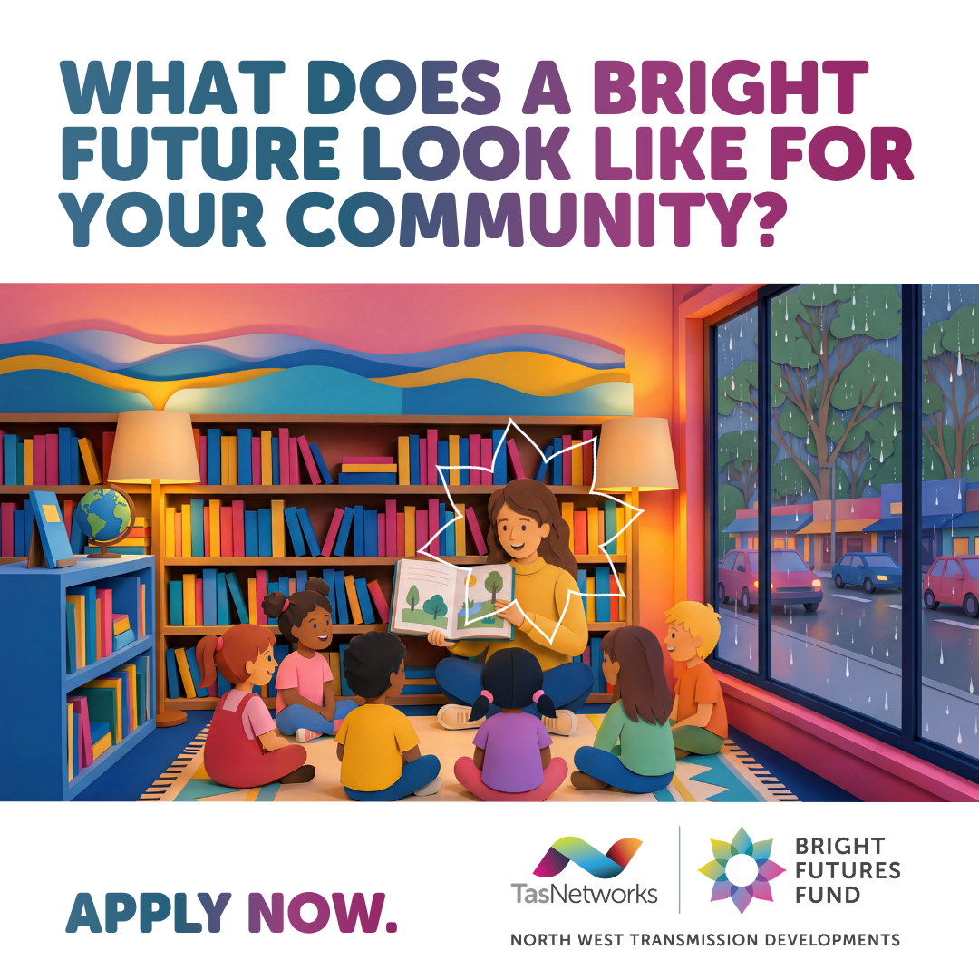

Post 3: Urgency / deadline
Have you looked into the North West Transmission Developments Bright Futures Fund yet? Applications close soon.
$10 million for projects across the North and North West. An independent local panel helps to decide where it goes. Ideas big or small, from a few thousand to a few hundred thousand.
What does a bright future look like for YOUR community?
https://www.tasnetworks.com.au/brightfuturesfund
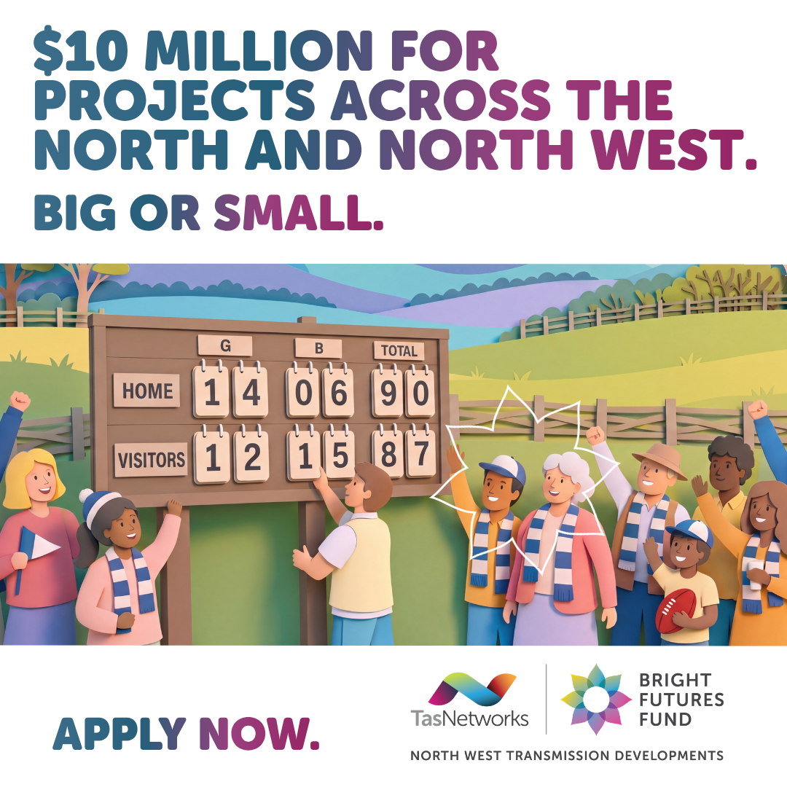

Ambassador Newsletter Assets
Drop-in blocks for org newsletters, email updates, council publications. Two lengths provided.
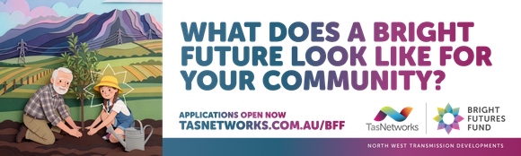
Short Version: 2–3 sentences + visuals attached
For sidebars, mentions, small newsletter spots.
TasNetworks' Bright Futures Fund is now open. $10 million for community projects across the North and North West, big or small. If your organisation has an idea, we encourage you to find out more.
Visit www.tasnetworks.com.au/brightfuturesfund

Long Version Body Copy + Visuals Attached
TasNetworks' Bright Futures Fund is now open, and we're encouraging everyone in our community to explore what it could mean for them.
The Fund is part of TasNetworks' North West Transmission Developments project. $10 million will be invested in community-led projects across the North and North West.
Delivering benefits across health, environment, arts, education and more. Projects can be big or small, from a few thousand to a few hundred thousand dollars.
What does a bright future look like for your community?
Find out more: www.tasnetworks.com.au/brightfuturesfund
TasNetworks. Powering a bright future.

