

Construction Audit Process

Underground Developments

Record Number: R0000389952 Version Number: 6.0

Date: March 2025

**Responsibilities**

This document is the responsibility of Electrical Safety Team, Tasmanian Networks Pty Ltd, ABN 24 167 357 299 (hereafter referred to as "TasNetworks").

Please contact the Electrical Safety Team with any queries or suggestions by emailing [authorisations@tasnetworks.com.au](mailto:authorisations@tasnetworks.com.au)

**Record of revisions**

|  |  |  |  |
| --- | --- | --- | --- |
| **Version** | **Section Number** | **Details** | **Date** |
| 1.0 | All | Initial version | January 2016 |
| 2.0 | Appendix 8 | Inclusion of final commissioning process | April 2016 |
| 3.0 | Appendix 8 | Addition of commissioning check sheet | April 2016 |
| 4.0 | Appendix 4 | Update of Works Change Request forms | May 2016 |
| 5.0 | All | Updated document to include commercial and Industrial subdivisions. Updated final commissioning process | September 2016 |
| 6.0 | All | Full document update | March 2025 |

Table of Contents

2. Purpose and Scope 4

3. Use of this document 5

4. Abbreviations 5

5. Communications 6

6. Audit Process 6

6.1 Audit Gates 6

6.2 Audit Criteria 8

6.3 Audit Results 8

6.4 Inspections and Notice Requirements 8

6.5 Observation Audits 9

7. Approved Materials 9

8. Subdivision Open Trench & Cabling Audit Questions 10

9. Subdivision Pre-commissioning & As-built Audit Questions 10

10. As-Built Documentation and Completion Records 12

# Purpose and Scope

This document outlines the audit process that applies to the construction of Underground Developments (UD) by a Developer under TasNetworks’ Connections Choice framework. It sets out the audit criteria that the Developer must comply with prior to commissioning and transferring to TasNetworks, and connection of the UD electrical infrastructure.

The process set out below is an overview only. Each audit will require collaboration between TasNetworks and the Developer to account for the Developer’s program of works and other specific requirements of each UD. For that reason, this document is to be read subject to:

* The terms of any Connection Contract between the Developer and TasNetworks; and
* The audit process agreed between the Developer and TasNetworks in relation to a specific UD.

For the purposes of clarification, UDs do not include the following:

* + Building Type substations
  + Fence type substations
  + Ground Mounted reclosers
  + Shopping centres
  + Large point loads
  + Embedded generation
  + Overhead networks including interface or transition point such as Overhead to Underground Poles.

The construction audit process should also be read in conjunction with all relevant TasNetworks standards and specifications, which may include the following documents:

* + Issue for Construction documentation
  + The Developer Guide for Underground Developments
  + TasNetworks Distribution Construction Drawings:
    - Kiosk Construction Drawings
    - Underground Construction Drawings
    - Public Lighting Construction Drawings
  + TasNetworks Distribution Construction Specifications and Standards:
    - TasNetworks Electrical Testing Specification
    - TasNetworks Materials and Assemblies Document
  + TasNetworks’ Environment & Heritage Design and Construction Standard
  + Guidelines when working near TasNetworks electrical assets

# Use of this document

This document will be updated periodically and is uncontrolled when printed. It is the responsibility of the Developer to ensure that the most recent version is used.

Nothing in this document should be relied upon by the Developer or any other person as a substitute for knowledge, experience, care or skill, or as a statement about that person’s legal rights or obligations. It is the responsibility of the Developer and its contractors to comply with all applicable laws, standards, and specifications (including relevant TasNetworks standards and specifications).

# Abbreviations

|  |  |
| --- | --- |
| **AED** | Accredited Electrical Designer |
| **AEC** | Accredited Electrical Constructor |
| **BoM** | Bill of Materials |
| **BoQ** | Bill of Quantities |
| **CC** | Customer Choice |
| **CP** | Conditional Proceed |
| **DLP** | Defect Liability Period |
| **ITP** | Inspection Test Plan |
| **JRA** | Job Risk Analysis |
| **NAO** | Network Access Order |
| **PC** | Practical Completion |
| **PL** | Portfolio Lead |
| **PoW** | Program of Work |
| **SWMS** | Safe Work Method Statement |
| **TN** | TasNetworks |
| **URD** | Urban Residential Development |
| **UD** | Underground Development which includes both URD and Commercial and Industrial subdivisions |
| **WH&S** | Workplace Health and Safety |
| **RFI** | Request for Information |

# Communications

TasNetworks and the Developer must each nominate at least one representative (**Nominated Representative**) to coordinate the audit process in relation to a development.

**Notice to Commence:** At least four weeks prior to construction commencing, the Developer must submit a Notice to Commence (as set out in TasNetworks’ Developer Guide).

The audit program involves several stages and discussions. It is critical to have continual communication throughout the project to ensure the best outcomes are achieved.

# Audit Process

## Audit Gates

The Audit Process agreed between TasNetworks and the Developer will be based around three ‘Gates’, two of these relating to a different stage of construction:

1. Subdivision Open Trench and Cabling Audit
2. Pre-commissioning Audit and As-built Audit
3. 2-year Defect Security Inspection Audit

The Audit process flow on the next page details the Subdivision Open Trench and Cabling Audit and the Pre-commissioning and As-built Audit lead times.

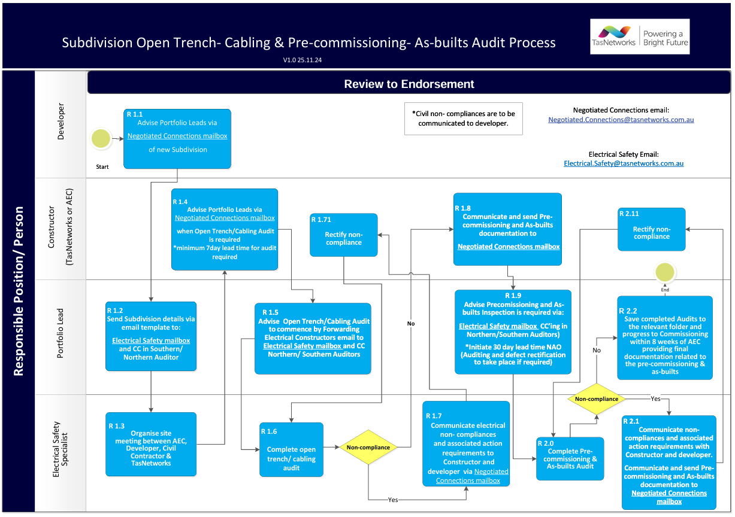

## Audit Criteria

The criteria that needs to be met in relation to each Gate is set out in the TasNetworks UD Audit Checklist (Section 8 and 9). In addition to those requirements, the audits must establish that the assets meet TasNetworks’ safety and operational requirements, including compliance with the approved (Issued for Construction) drawing and any relevant TasNetworks standards and specifications.

## Audit Results

After each Gate, TasNetworks will issue the Developer/AEC with a report indicating whether the works have passed the audit, with one of three results:

|  |  |  |
| --- | --- | --- |
|  | **Result** | **Consequence** |
| **Pass and proceed** | Pass: No findings | The Developer/AEC may continue with construction until the next inspection point set out in the Audit Program. |
| **Conditional proceed** | Findings: TasNetworks will provide the Developer/AEC with details of the defect identified and the rectification requirements. | Only after the defects have been corrected and assigned actions completed can the Developer/AEC proceed with construction until the next inspection point set out in the Audit Program. |
| **Hold** | Findings: TasNetworks will provide the Developer/AEC with details of the defect identified and the rectification requirements. | The Developer/AEC must cease construction until the defects have been rectified. |

## Inspections and Notice Requirements

While based on the three Gates, the specific number and proposed timing of inspections for each project will be agreed by TasNetworks and the Developer/AEC at the Early Engagement Meeting.

The Developer/AEC must provide the TasNetworks Liaison Officer with written notice of readiness to indicate when the works have reached an inspection point as set out in the Audit Program.

TasNetworks will use its best endeavors to conduct inspections within the following timeframes:

|  |  |
| --- | --- |
| **Gate** | **Minimum notice period** |
| Subdivision Open Trench and Cabling Audit | Seven business days’ written notice |
| Pre-commissioning Audit and As-built Audit | At least thirty business days’ written notice for NAO application |

In certain circumstances, despite TasNetworks’ best endeavours, TasNetworks may be unable to schedule an inspection within the above timeframes or may be required to defer or cancel inspections (e.g. during a natural disaster or other emergency). In such cases the Developer/AEC must not proceed with construction until the relevant Gate has been passed. Unless it has been inspected and approved by TasNetworks, no transferable asset should be concealed, covered, buried or otherwise treated in a manner that will result in that component not being readily visible to a person attempting to view it. Any asset that is concealed or covered prior to inspection by

TasNetworks must be uncovered at the Developer’s/AEC’s cost.

## Observation Audits

TasNetworks may conduct observation audits in addition to the Audit Program at any time provided that:

* + 1. TasNetworks will inform the AEC in advance that it intends to conduct an observation audit.
    2. The Developer’s Nominated Representative may, but is not required to, attend an observation audit.
    3. If any defects are identified during an observation audit, TasNetworks will provide the AEC with a written report containing details of the defect(s) and the rectification requirements.
    4. If the Developer’s Nominated Representative is not in attendance at the observation audit, TasNetworks’ Nominated Representative will photograph any non- compliances and provide a copy of the photographs to the Developer’s Nominated Representative.

# Approved Materials

It is a requirement of the Connection Contract that the Customer/Developer use equipment and materials from TasNetworks Approved Materials List. TasNetworks will check to ensure that any equipment and material used in the UD meets this requirement as part of each audit.

Unless otherwise agreed with TasNetworks, any material and equipment which does not comply with TasNetworks’ Approved Material List will be considered as non-compliant and result in a Hold Point until rectified.

Any pre-installation test that fails will result in a Hold Point for the UD and will require an additional site visit to witness successful pre-installation tests.

# Subdivision Open Trench & Cabling Audit Questions

* Has the Subdivision been constructed as per Design and TasNetworks’ standards requirements?
* Are boundary pegs and road reserves marked on site?
* Is trenching to alignment and depth?
* Have open trenches been surveyed?
* Have trenches been excavated as per the approved design?
* Does electrical infrastructure have minimum separation from other services?
* Are minimum clearances maintained as per trench arrangements and design standards?
* Has the correct bedding material for the trench been utilised?
* Is bedding sand free of stones, organic material and salts?
* Have cable conduits been installed through a water course or open drain?
* Are the customers service conduit depths and direction correct?
* Are the correct conduit bends being utilised as per design?
* Have conduits been joined correctly?
* Have cables and conduit(s) been installed as per the approved design?
* Are cable bends radiuses within tolerance?
* Are cable joints completed as per design?
* Has cable cover been installed as per trench arrangements and design standards?
* Has marker tape been installed as per trench arrangements and design standards?
* Have road crossings been installed, completed as per approved design?
* Is all backfilling for trenches and street furniture, including foundations, of an approved material and compacted in layers?
* Has a method other than open trenching been used (i.e. bore activity)?
* Has the substation earth mat been installed as per the approved design?
* Are street furniture location and installation as per the approved design?

# Subdivision Pre-commissioning & As-built Audit Questions

* Has the Subdivision been constructed as per Design and TasNetworks standards requirements?
* Do located cable depths comply with the design trench detail requirements?
* Is the orientation and height of the streetlight rag bolts correct?
* Has streetlight rag bolts thread protection (Denso tape) been installed?
* Are the street light foundations and concrete pad compacted and at the correct depth, as per standards and/or as per design?
* Are the street light foundations for direct buried compacted and at the correct depth as per standards and/or as per design?
* Have service conduits been capped and draw cord installed?
* Are the ends of each conduit run, including turrets, cabinets, public lighting and kiosk subs capped to prevent ingress of moisture and contaminants prior to cable installation?
* Are the ends of each conduit run, including turrets, cabinets, public lighting and kiosk subs when cables are installed, sealed with polyurethane expanding foam?
* Has a mechanical protection (polymeric) cover been installed as per the standards and/or as per design?
* Has the caution marker tape (warning tape) been installed as per the standards and/or as per design?
* Are underground cable and duct placement crossings marked?
* Have surface cable markers been installed relating to High Voltage cables?
* Have all UG cables been surveyed? (GPS coordinates required for handover)
* Has the Electrical Street Furniture (turrets and cabinets) been surveyed? (GPS coordinates required for handover)
* Is the Street Furniture location and type as per the approved design?
* Does the street furniture distance from boundaries and driveways comply with the standards and/or the design?
* Is the Street Furniture (turrets and cabinets) installation height correct?
* Is the Street Furniture fixed to bases or foundations correctly?
* Is the Street Furniture plumb and aligned correctly?
* Have Substation retaining walls and drainage be installed per the standards and/or as per design?
* Are Substations locked and/or secured?
* Has the correct Substation plinth been installed?
* Is all furniture earthing, including MEN's completed as per standard? (Under five hundred ohms)
* Is earth labelling as per the standards and/or as per design? (Compliance to AS3000)
* Are street furniture fuse panels wired and fitted correctly?
* Are street furniture terminations and connections acceptable?
* Have street furniture and kiosk fuses been installed as per the standards and/or as per design to the correct rating?
* Is the street furniture numbered and labelled correctly as per the standards and/or as per design?
* Has all cable termination covers and boots (Trification) been installed?
* Are all Substation cable terminations correct, and all circuits labelled as per one line diagram?
* Are the Substation circuit breaker ratings and settings correct as per the contractors workorder or design?
* Is the survey plan aligned with the red line drawings?
* Have all relevant tests and associated documentation been completed to standard and submitted to TasNetworks?
* Has Substation/HV switchgear earth testing been witnessed by TasNetworks?
* Has Street Furniture Electrical Compliance Testing been completed to TasNetworks’ Standards and witnessed by TasNetworks?
* Has all relevant As-builts documentation and information been completed in its entirety, and returned to TasNetworks Portfolio Leads?

# As Built Documentation and Completion Records

The Connection Contract contains several preconditions to issue the Certificate of

Acceptance including the provision of “as built” documentation by the Developer which shall include but not be limited to:

* Copy of the approved design/s
* Approved BoM with quantities
* Signed Red line mark ups on design to prove compliance
* Electrical Testing documentation
* Excavation and or trenching permits
* Inspection Test Plans (ITPs)
* Network Access Order (NAO)
* Power system access
* Electrical and Civil Work Certification
* Site photographs if requested
* Bore logs
* Environmental, Aboriginal Heritage, European Heritage and Stakeholder Permits (including council permits)
* Easements and Wayleaves
* GIS survey details
* Copies of all delivery dockets of major equipment